WAYS TO UNSUBSCRIBE TO AN OBSERVABLE

|  |
| --- |
| LEGEND  NR : Not Recommended  R : Recommended |

METHOD -1 (NR)

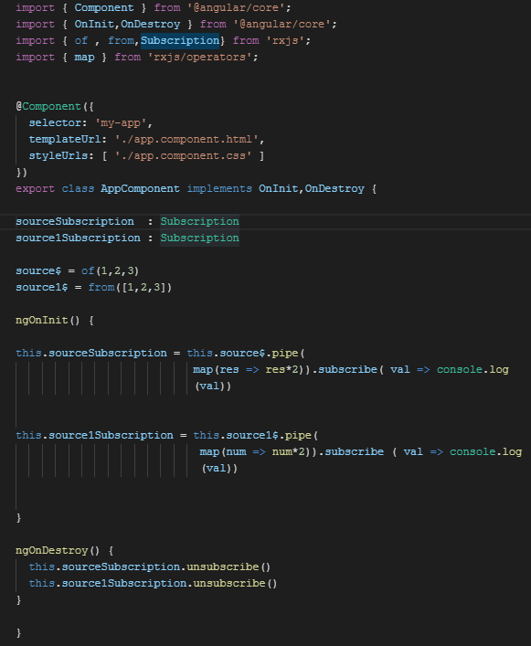

METHOD -2 (NR)

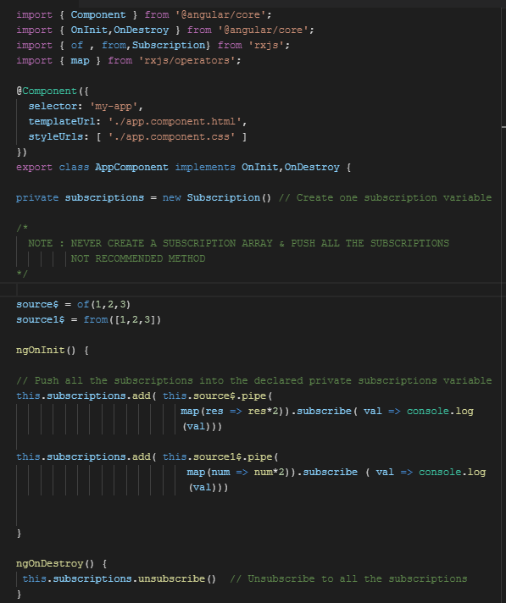

METHOD-3 (NR)

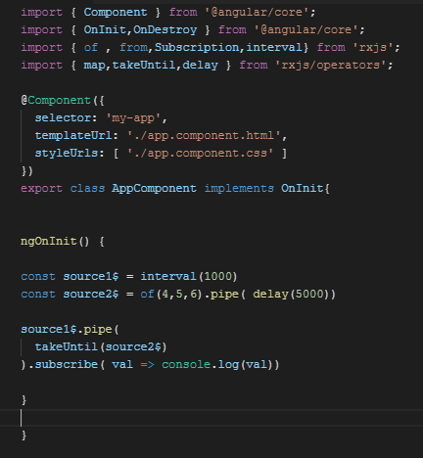

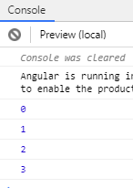

METHOD-4 (R)

